Input: Tab-delimited .txt format file with header
- File 1: Sample—Environment. The first line is the sample name, the first column is the environmental factor, and the second column is the content of each environmental factor in each sample.
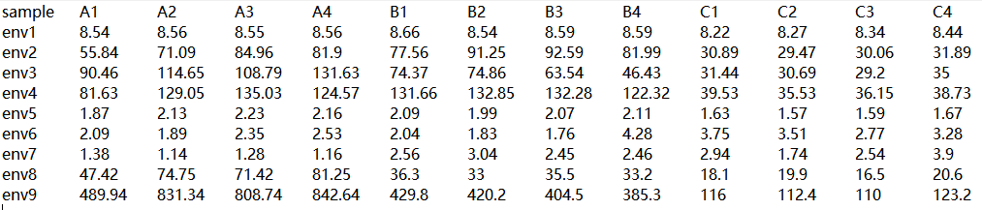
- File 2: Sample-Species, the first row is the sample name, the first column is the species name, and the second column is the abundance of each species in each sample.
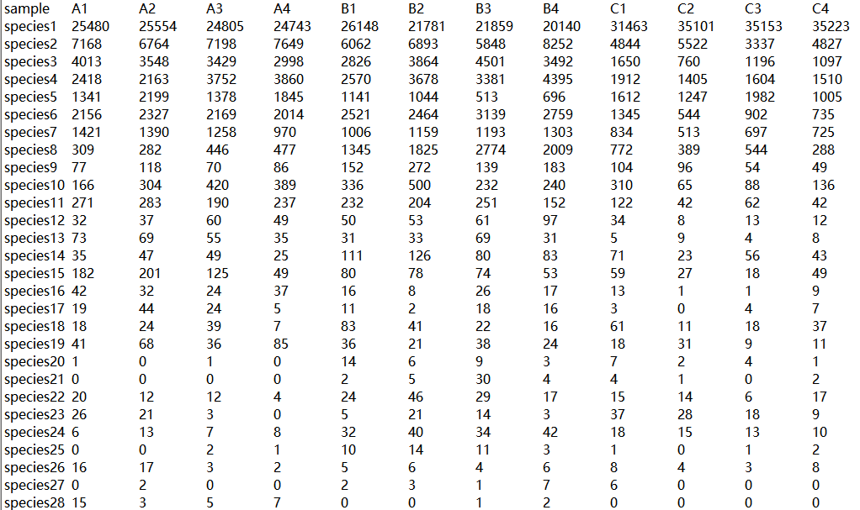
- Group file: The first column is the sample name, and the second column is the group name.
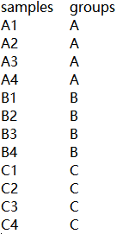

Parameter:
1. File name: file 1 (environments), file 2 (species)
2. Dimensionality reduction method: PCA
3. Point size: 4
4. Line thickness: 1.5
5. Picture title: relationship
6. Group color: #FF0000, #0000ff, #ff6600

Output:
The result file is compressed, and two types of result graphs with sample label (procrusters.lab) and without label (procrusters) are output at the same time, including PDF and PNG formats, and the other files are OS platform source files.
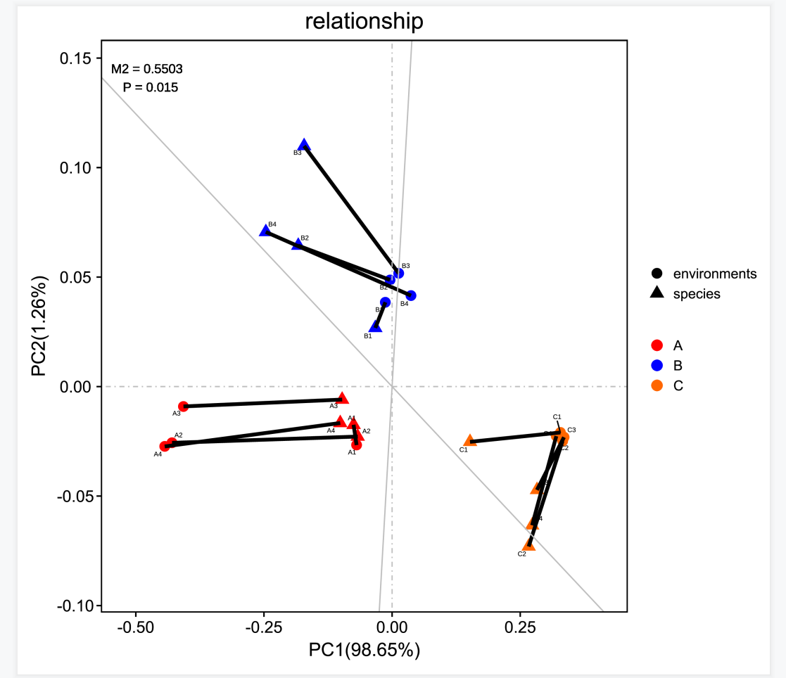
Interpretation of the results:
1) Different colors in the picture represent different groups;
2) The point mapped on the main orthogonal axis is the sample point from the environmental variable PCA, represented by a circle, and the point mapped on the oblique orthogonal axis is the sample point from the PCA composed of species, represented by a triangle;
3) The line indicates the paired quadrat of the two, the length of the line segment is the residual value between the two, the shorter the line segment, the smaller the residual value;
4) M² is the sum of squares of the residual values. The smaller the value of M², the better the consistency of the two sets of data. From the graphical results, it can be seen that the potential relationship between the environment and the species shows better consistency (P< 0.05).

