Function: A method used to analyze the correlation between two sets of data and compare the consistency of two sets of data, such as analyzing the relationship between microbial species composition and the environment.

Input:
1. The file must be a tab-separated .txt format file with a header. The name of the table consists of letters, numbers, and underscores, and no suffix name is allowed.
2. Input two sets of data for analysis in sequence. File 1 defaults to the main orthogonal axis data. The first row of the data table is sample information, the first column is specific parameters, such as species, genes, etc., and the second column is the abundance of species or genes in the corresponding sample.
3. Enter the grouping data. The first column of the data table is the sample name, and the second column is the group to which the sample belongs.
Examples:
File 1
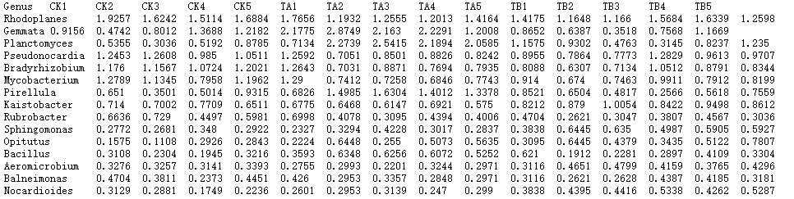
File 2
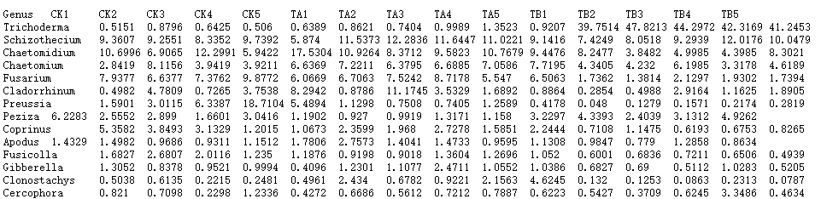
Groups
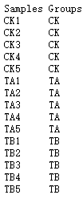

Parameter:
1. File name: custom(English characters)
2. Dimensionality reduction method: PCA (suitable for data matrix with a large number of samples)/PCoA (suitable for data matrix with a small number of samples)
3. Point size: custom
4. Line thickness: custom
5. Picture title: custom(English characters)
6. Group color: custom (add the same color type as the number of groups)

Output: After the analysis is completed, a compressed folder of drawing results will be provided for download, which contains the result images in PDF and PNG formats.
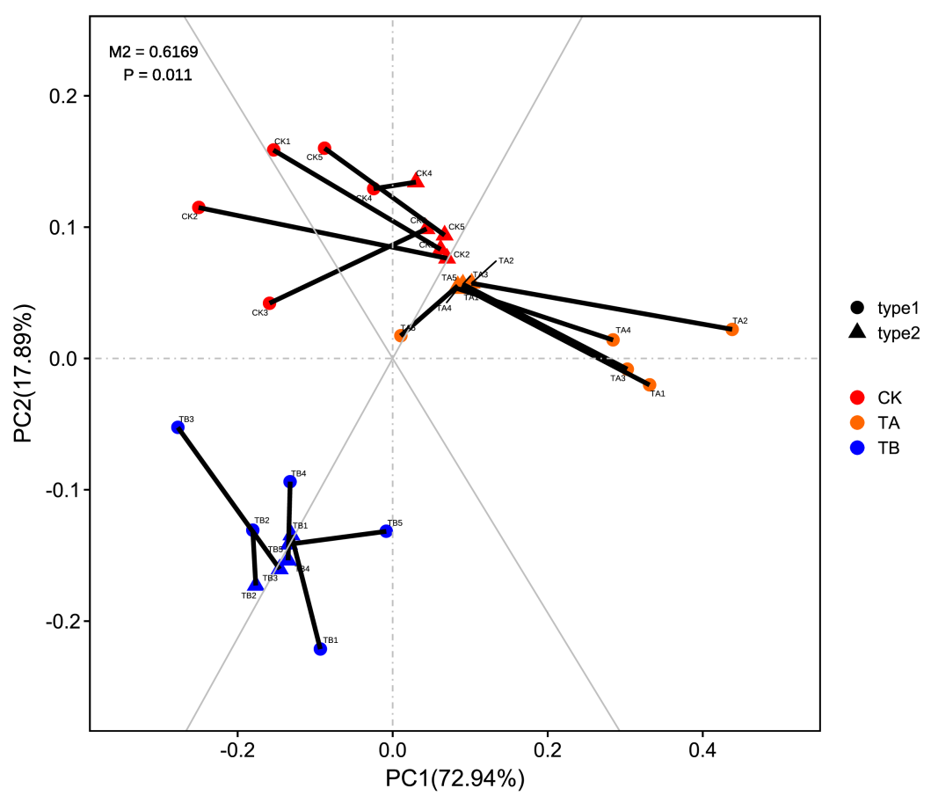
Interpretation of the results:
1) Different colors in the picture represent different groups;
2) The point mapped on the main orthogonal axis is the sample point from File 1 PCA, represented by a solid circle, and the point mapped on the oblique orthogonal axis is the sample point from File 2 PCA, represented by a triangle ；
3) The line indicates the paired samples of the two, the length of the line segment is the residual value between the two, the shorter the line segment, the smaller the residual value;
4) M² is the sum of the squares of the residual values. The smaller the M² value, the better the consistency of the two sets of data. Use permutation test to calculate the M² significance P value.

