Input: .txt file with header, the first column is the country name code, the second column is the statistics of COVID-19 in various countries

Parameter:
1. Picture caption: Statistics of COVID-19 in various countries
2. Label: Display
3. Data: Display
4. Data
5. Border: display
6. Drawing direction: clockwise
7. Label display: inside the column
8. Preset group color: rainbow

Output:
The result file compression package contains the result images in PDF and PNG format, as well as the source files of the OS platform.
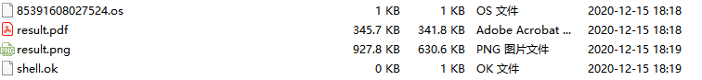
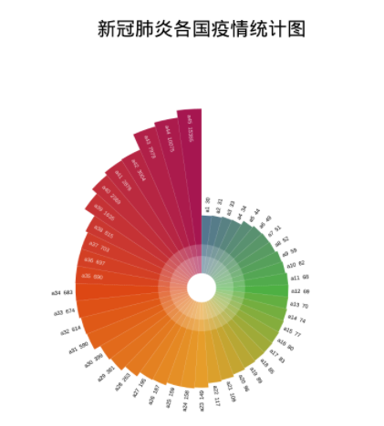
Interpretation of the results: different colors represent different countries. The length of the column indicates the number of people in each country. The longer the column, the more the number of people infected, and vice versa.

