Function:
Similar to the grouped violin chart, the two groups are combined into a violin chart to display, which is convenient for visually comparing the data distribution state between the two groups, and is suitable for displaying multi-factor data distribution.

Input：
- Format: The file must be a tab-separated .txt format file with a header. The name of the table is composed of letters, numbers, and underscores. The file name cannot have a suffix.
- The first row of the file "a/b/c/d" is the X-axis parameter, which can be different samples, different genes, different clusters, different time gradients, etc.; the first column is the Y-axis parameter attributes, which can be gene ID, cell barcode, Samples, etc. The corresponding content (value) can be gene expression, cell UMI, tumor volume, etc.
- In the two sets of files, the number of columns in each set of files and the names of the corresponding columns must be consistent.

Example
Group1 Group2
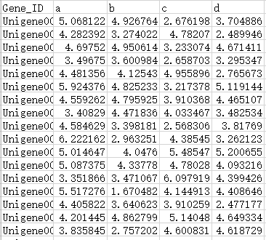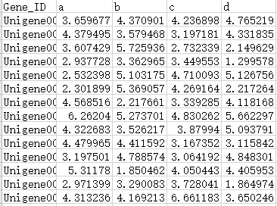

Parameter:
1.Input file, input two files in sequence, file 1 corresponds to group 1, file 2 corresponds to group 2, you can customize the group name and color, if not selected, the system default name and color.
2. X axis title: custom
3. Y axis title: custom
4. Graphic title: custom
5. Scattered points: show or not show

Output:
- Picture: The program will output bean pictures in PNG and PDF formats.
- Table: The program will output a table in .xls format containing the average, minimum, maximum, upper and lower quartiles and median information of each group of each sample.

Explanation of results:
- The graphic interpretation is as follows:
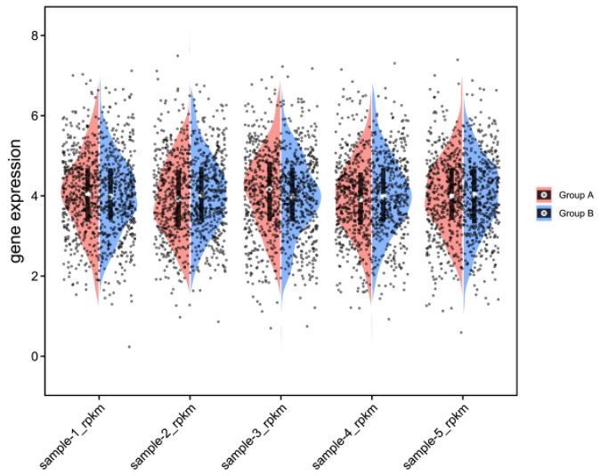
①Different colors in the figure represent different components, and each point represents a piece of data;
②The white dot in the black rectangle represents the median Q2. The higher the relative position of the white dot between the groups, the higher the overall distribution of the data in the group. The corresponding biological significance is the higher the gene expression/detected cell UMI The more the number / the larger the tumor volume, etc.;
③The length of the black rectangle represents the difference between the upper and lower quartiles (IQR) in this set of data. The longer the rectangle, the more scattered the data, and the shorter the more concentrated; the upper edge of the rectangle is the upper quartile Q3; the lower edge is the lower fourth Quantile Q1;
④The outline of the bean graph represents the main interval of the data distribution, and the data outside the outline is discrete data; the two ends of the vertical axis of the outline represent the minimum and maximum values, and the longer the vertical axis, the greater the degree of data dispersion; the horizontal axis The direction length represents the data distribution density, and the longer it is, the more data is distributed in the corresponding ordinate position.

- The interpretation of the table is as follows:
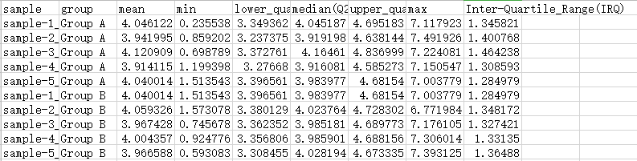
Header attributes: the first column corresponds to the X-axis content of the bean chart; the second column is the grouping information; the third column is followed by the average (mean), minimum (min), lower quartile (Q1), Median (Q2), upper quartile (Q3), maximum value (max), upper and lower interquartile range (IRQ).

