Input: .txt file with header, the first column is the gene ID, the 2-6 columns are the gene expression in each sample
g1：Group A
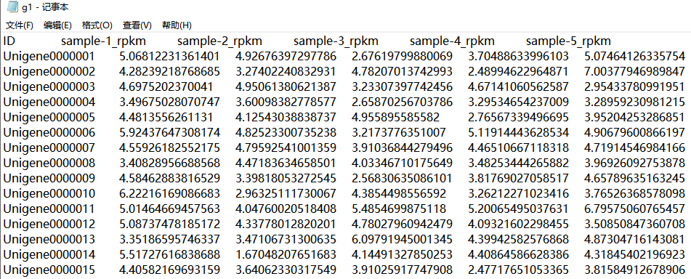
g2：Group B
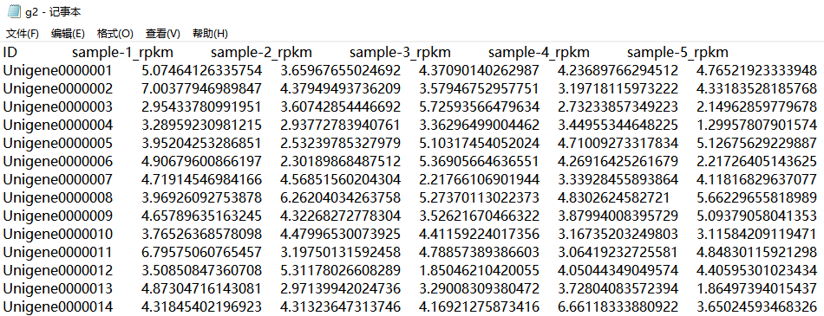
Parameter:
1) Group color: default
2) X-axis title: None
3) Y-axis title: gene expression
4) Graph title: None
5) Scattered points: don’t display

Output:
- Result file compression package
Contains two OS tool source files, PDF and PNG format result graphs, excel statistical result table
- Result graph
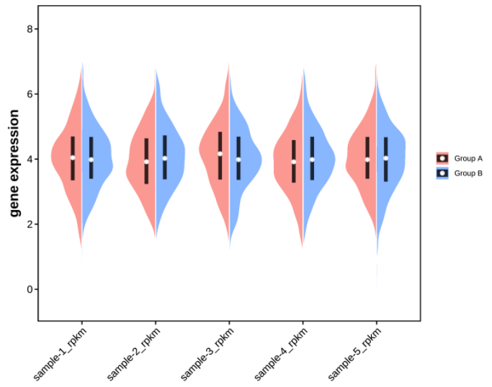
- Result table
