蜂群图英文例子说明

Input：.txt file with header
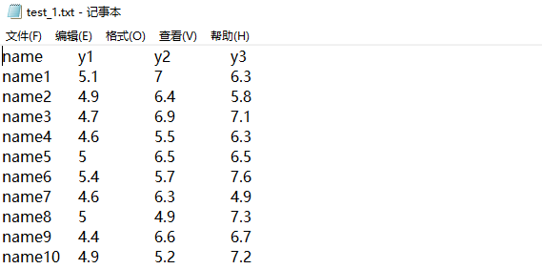
Parameter：
X-axis title：sample
Y-axis title：gene expression

Output：
- Result file compression package

Contains the OS tool source files, PDF and PNG format result graphs
- Result graph
