Function：
Using the enrichment analysis results draw Dynamic enrichment difference bubble plot, Contains four data types GO/KEGG/DO/Reactome
Input：
- Format: The file must be a tab-separated .txt format file with a header. The name of the table is composed of letters, numbers, and underscores. The file name cannot have a suffix.
- Drawing method：Read the data in the form of column numbers, specify that the fourth column is the number of up-regulated genes, the fifth column is the number of down-regulated genes, and the sixth column is the P/Q value. The first 20 rows of data with the smallest P/Q value are selected to draw a bubble chart.
- File types:
Type1: contains 6 columns of data
Column 1: Class I/Class A
Column 2: GO/KEGG/DO/Reactome comment ID number
Column 3: Term/Pathway name
Column 4: The number of differentially up-regulated genes belonging to this pathway
Column 5: The number of differentially down-regulated genes belonging to this pathway
Column 6: P value/Q value of enrichment analysis
Note: In the final drawing, the abscissa up-down normalization=(number of differentially up-regulated genes - number of differentially down-regulated genes)/(number of differentially up-regulated genes + number of differentially down-regulated genes)
The table of four data types is shown below:
GO database
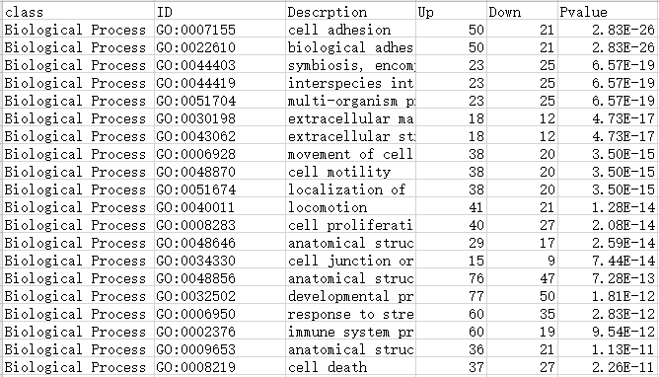

KEGG database
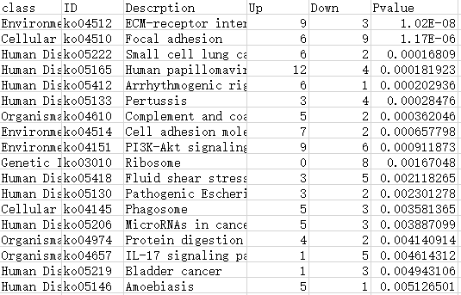
DO database
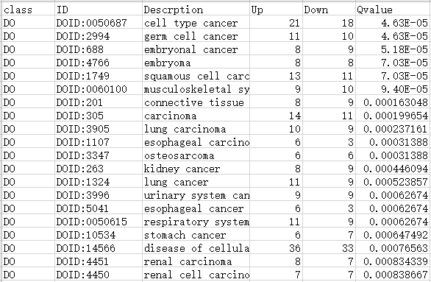
Reactome database
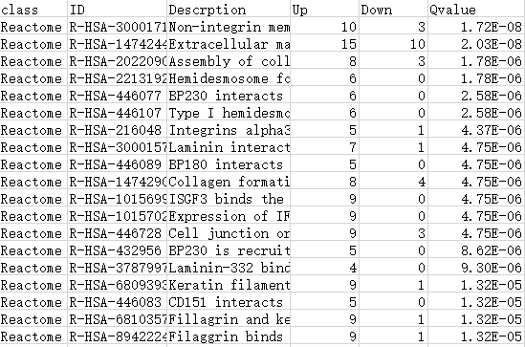

Type2: Include more data information
Column 1: Class I/Class A
Column 2: GO/KEGG/DO/Reactome comment ID number
Column 3: Term/Pathway name
Column 4: The number of differentially up-regulated genes belonging to this pathway
Column 5: The number of differentially down-regulated genes belonging to this pathway
Column 6: P/Q value of enrichment analysis
Column 7: Differentially up-regulated genes ID
Column 8: Differentially down-regulated genes ID
Note: In the final drawing, the abscissa up-down normalization=(number of differentially up-regulated genes - number of differentially down-regulated genes)/(number of differentially up-regulated genes + number of differentially down-regulated genes)
The table is shown below:
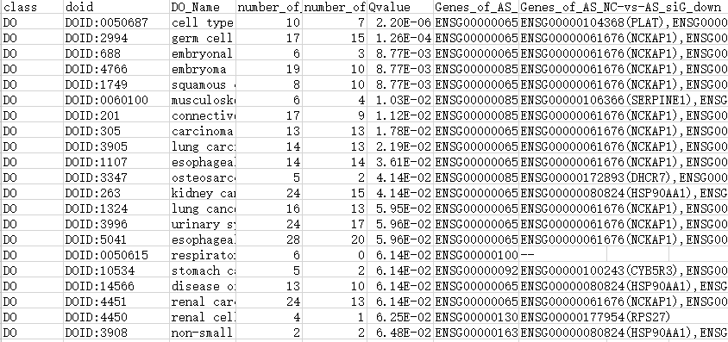

Parameter selection:
- Parameter: choose P-value or Q-value to draw bubble chart according to your needs. Choosing different parameters will affect the final graphical result;
- Type: Contains four enrichment analysis databases of GO, KO, DO, and Reactome. Choose the corresponding type according to the source of the table data.

Parameter adjustment:
- Graphic title: set or modify the title of the graphic
- X/Y axis title: set or modify X/Y axis title
- Transparency: Set the transparency of bubbles
- Display ID/Bubble Stroke/Coordinate Scale Line/Graph Border/Legend/Grid Line: Set whether to display
- Baseline modification: Customize the baseline color and thickness
6) Modification of bubble color: set the first level classification color of GO/KO/DO/Reactome
7) Modification of bubble size: set the size of the bubble in the graph
8）Reset: restore the default settings of the picture

Output：
The program will output the enrichment difference bubble plot as required, and the user can adjust the parameters according to personal needs. The result file can be downloaded in SVG and PNG formats.

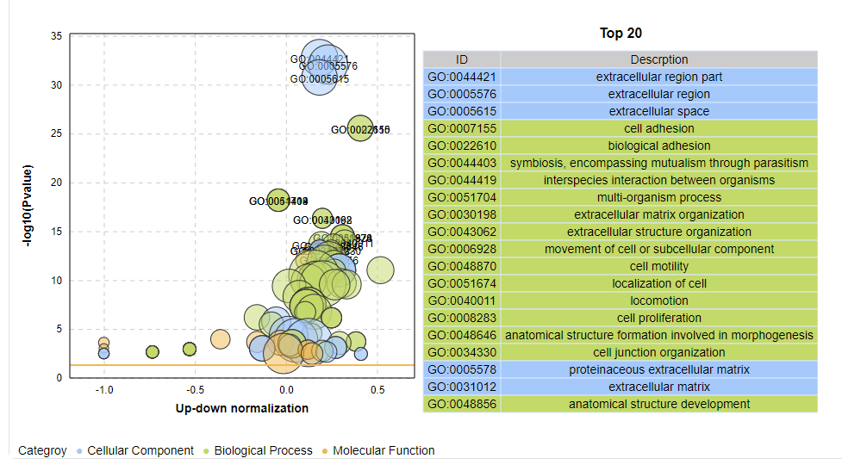
Description:
The ordinate is -log10 (Q/Pvalue), and the abscissa is the up-down normalization value (the ratio of the difference between the number of up-regulated genes and the number of down-regulated genes in the total differential genes); the yellow line represents the threshold of Q/Pvalue=0.05 ; On the right is the term/Pathway list with the top 20 Q/P values. Different colors represent different Ontology/A classes.

